TASK 33 : ADD A SLAVE NODE • Activity: • Add a slave node (Ubuntu instance) to the Jenkins master • Steps: • Go to Manage Jenkins -> Manage Nodes and clouds -> New Node • Give a node name and select permanent agent • Enter the Host details and directory as /home/ubuntu. Please note to enter IP • Select launch method to be launch with ssh. • Select Add credentials and ssh username with key option provide the pem file details there. • Select non verifying strategy. • Make sure to install java on the slave node. sudo apt-get update sudo apt-get install default-jdk

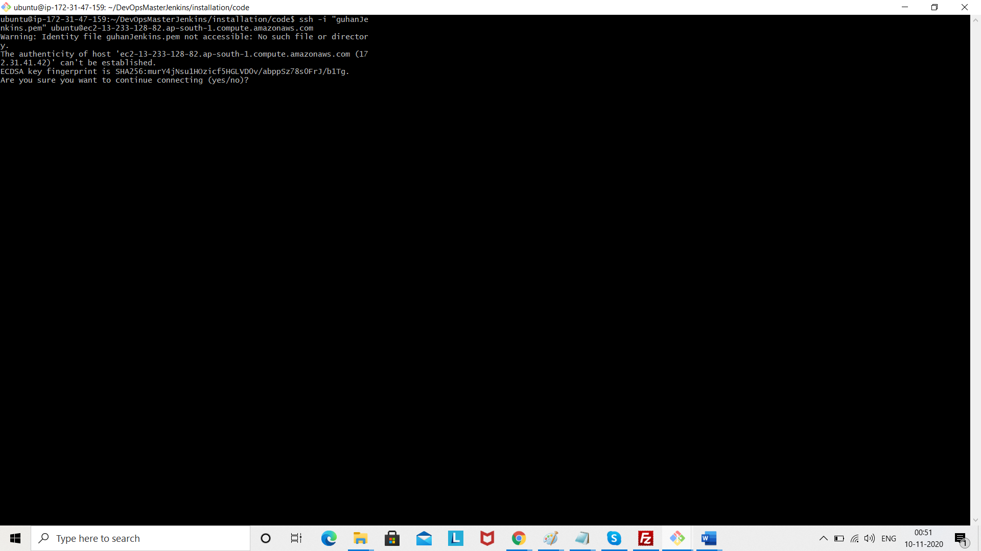

Click yes

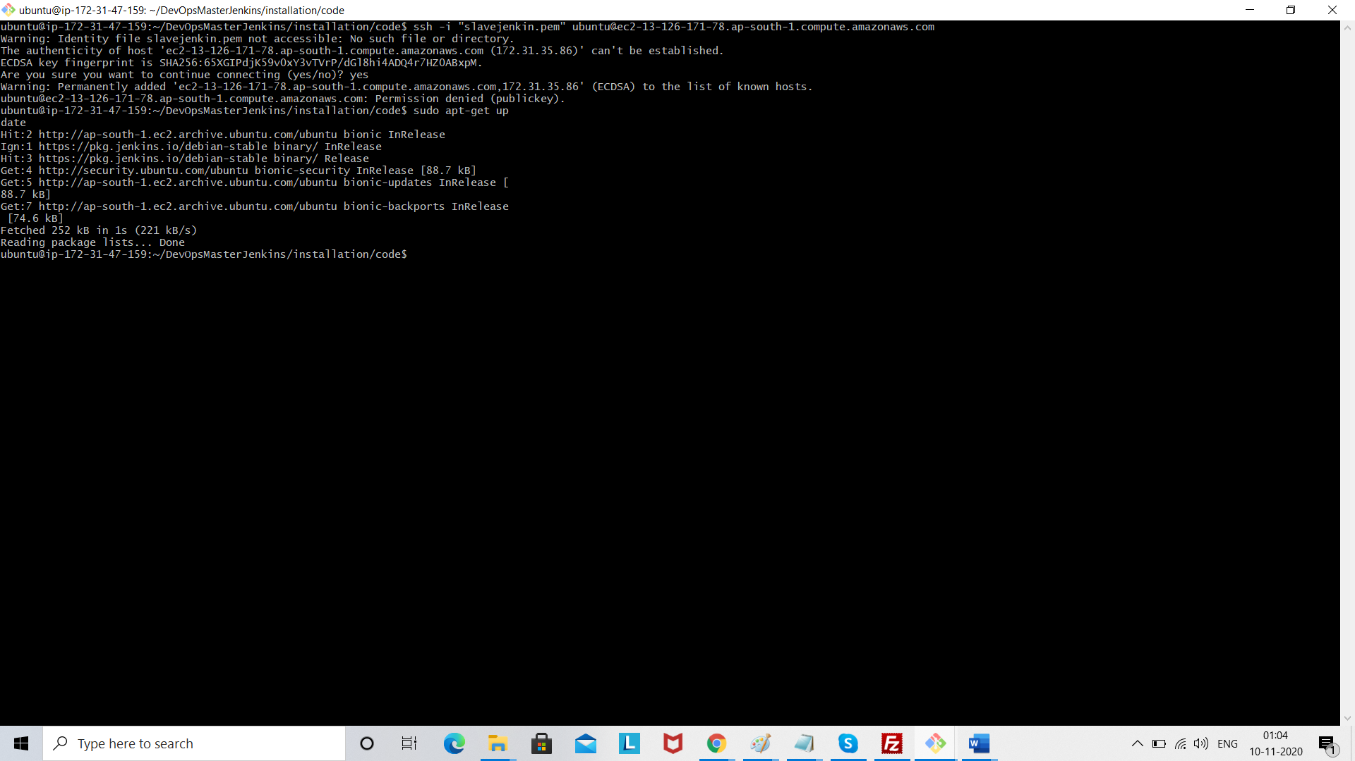

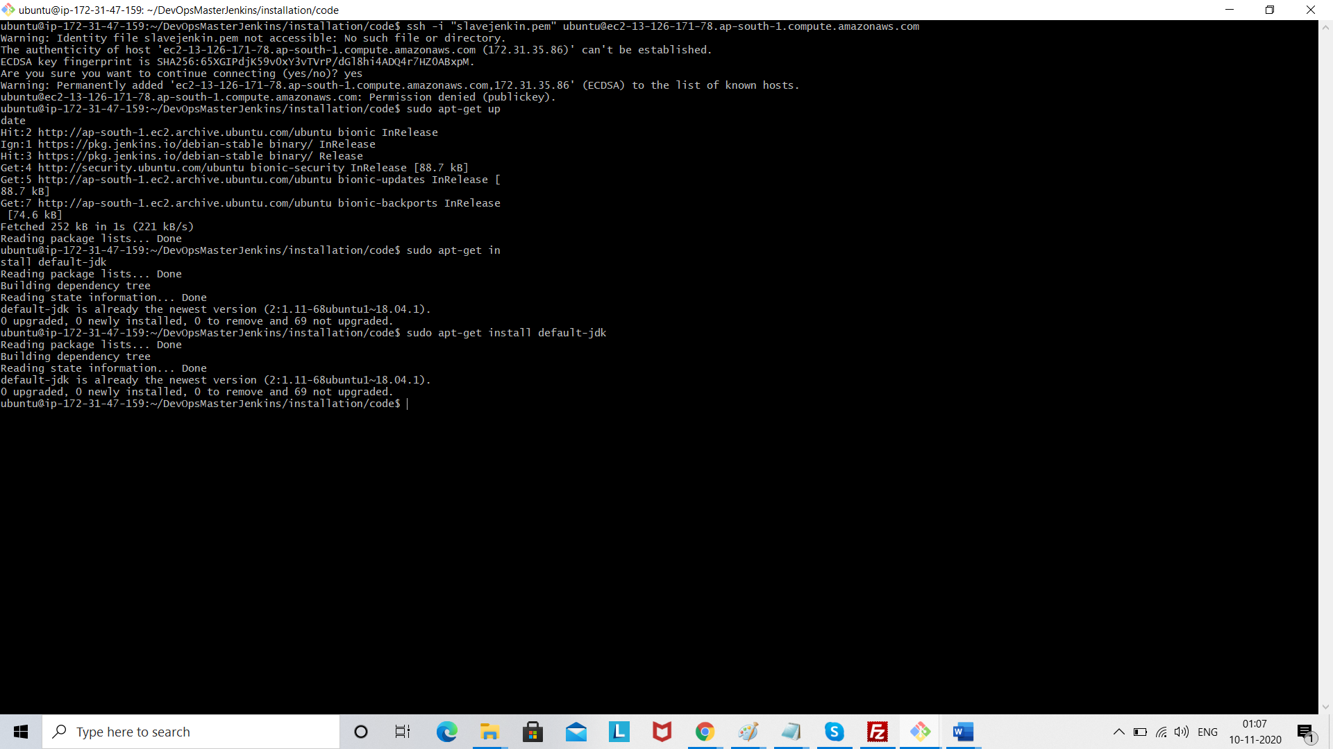

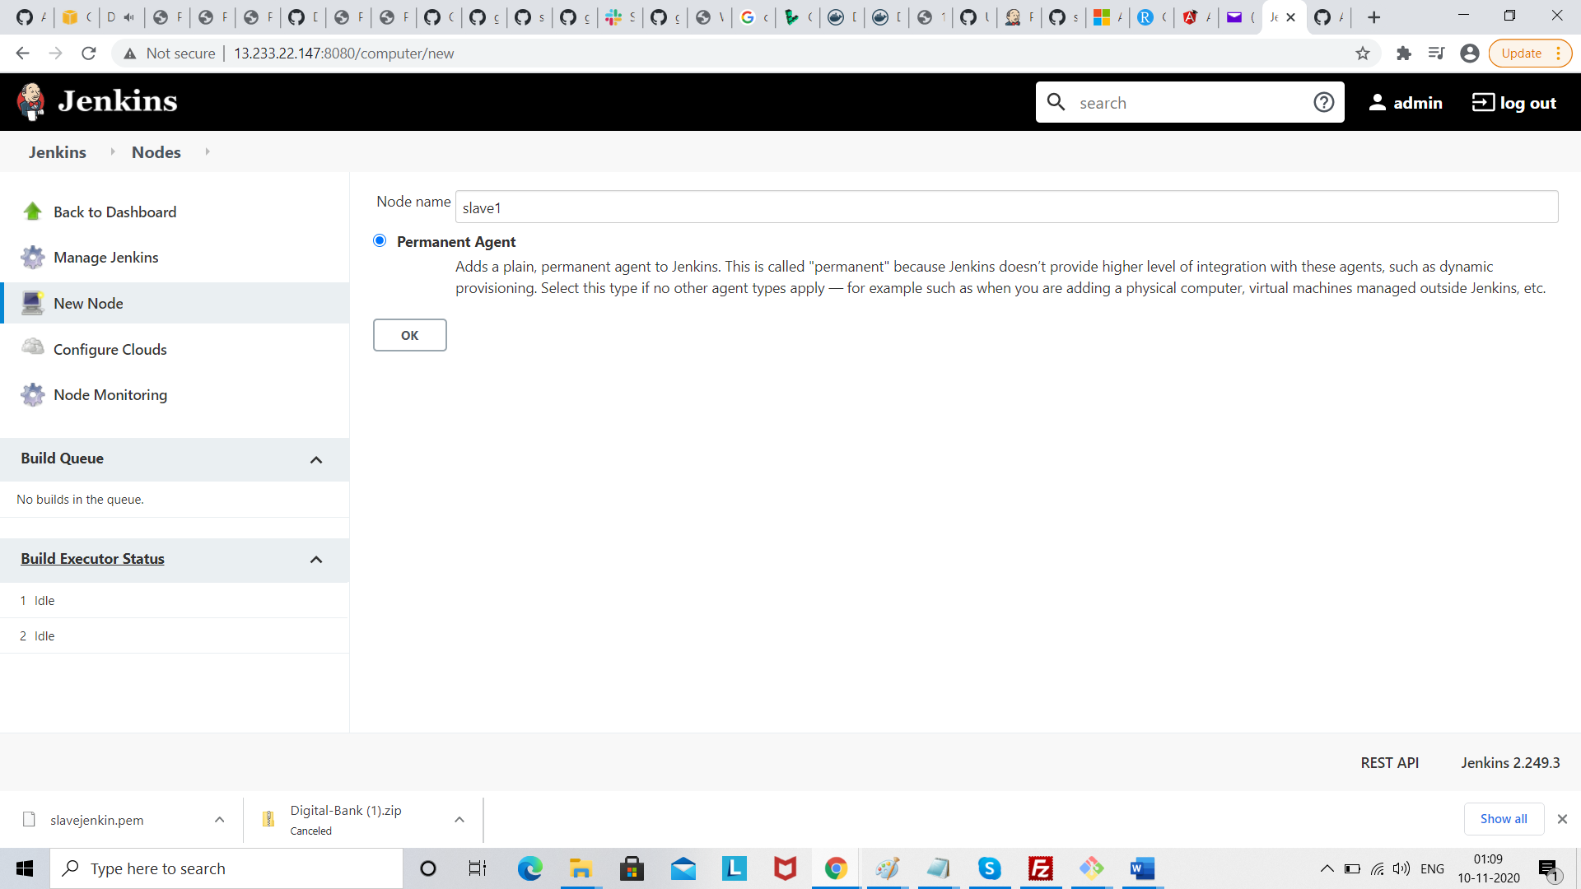

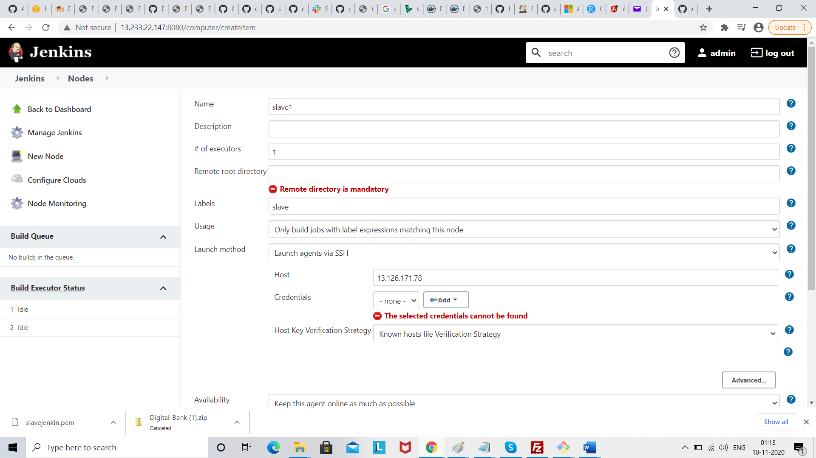

Click credential add

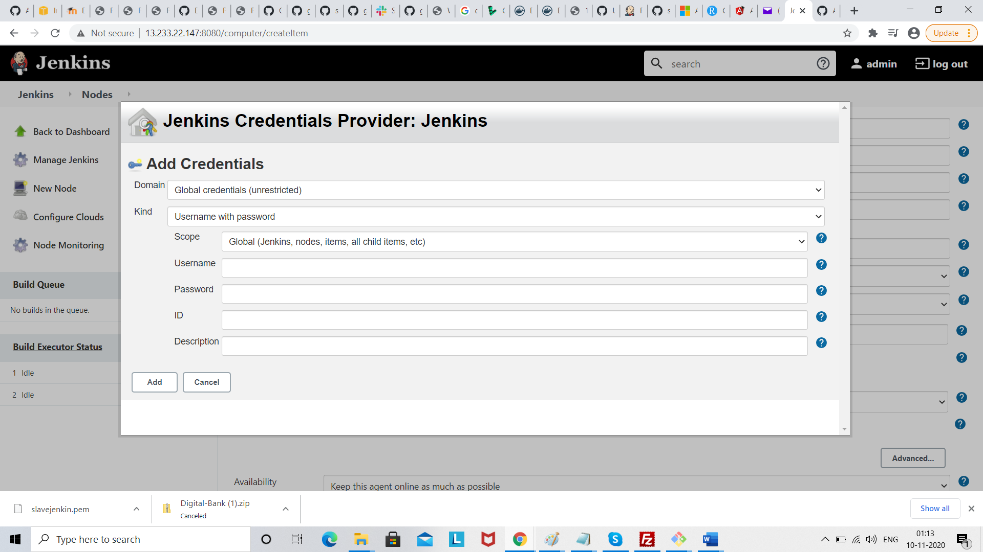

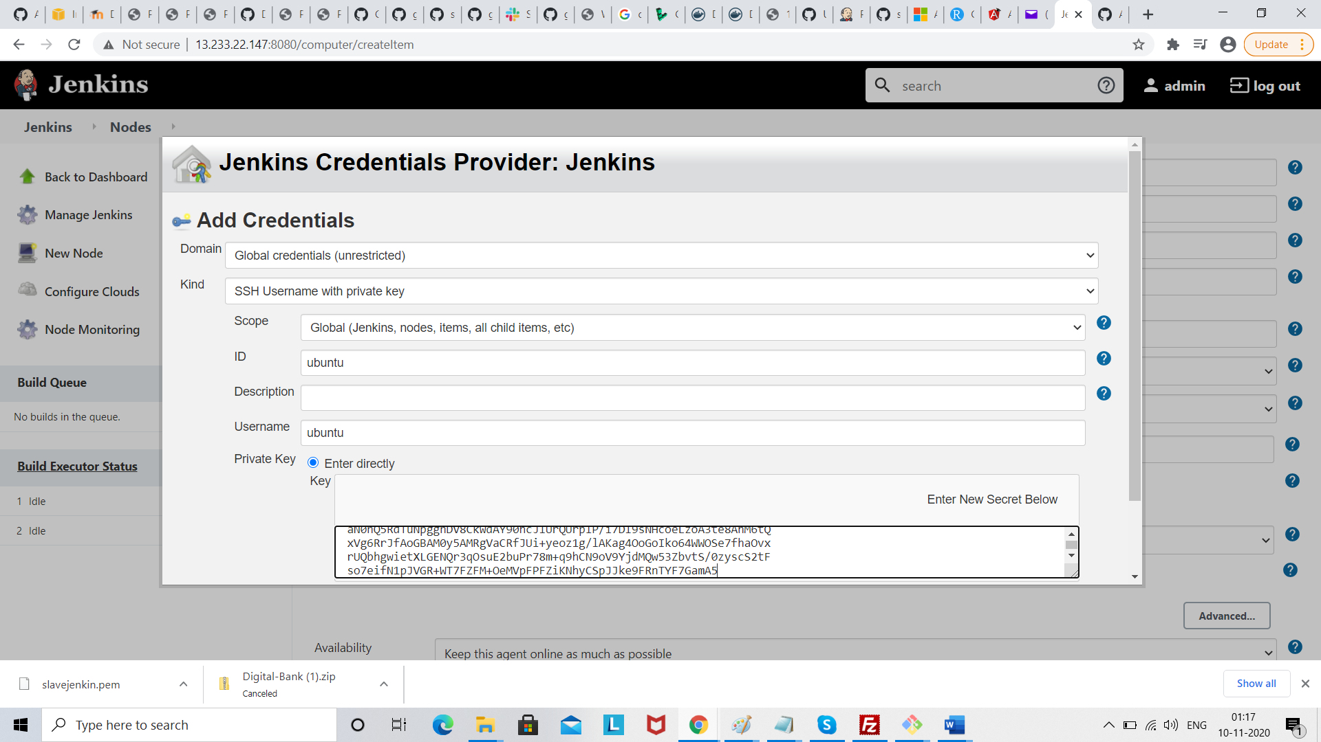

Click add

